Database Systems Lab 6 Task

Name = Poorab Gangwani

Class = 4B1

Roll-Number = CS191092

1)

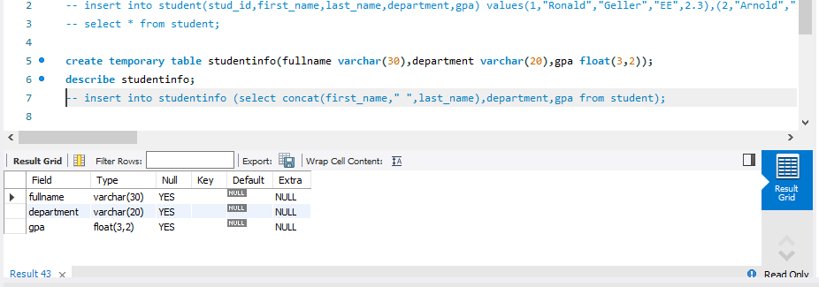

2)

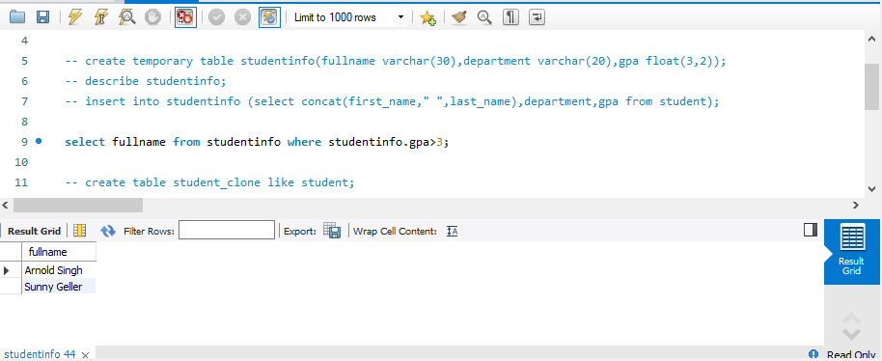

3)

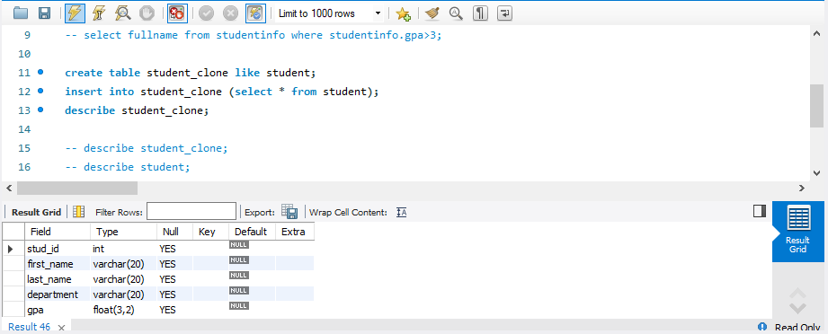

4)

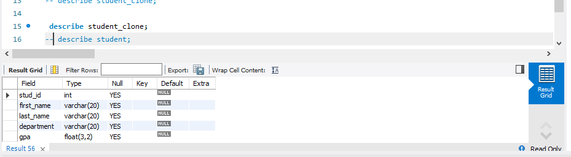

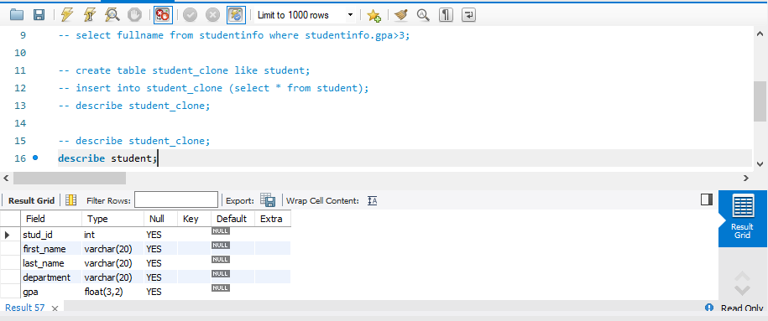

5)

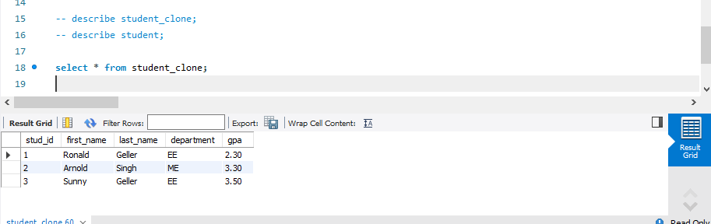

6)

